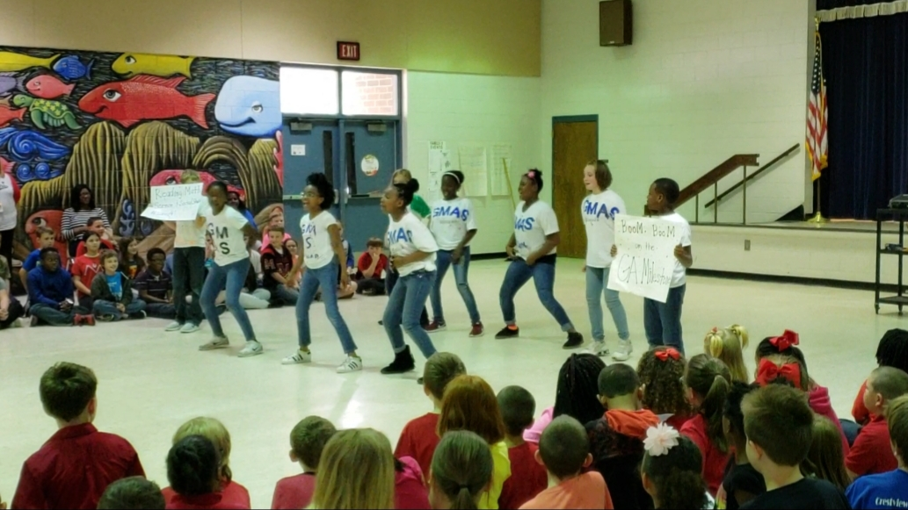  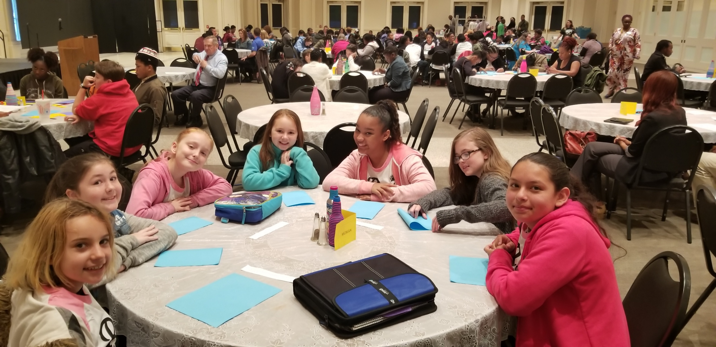  Get Involved at McBean Elementary  There are multiple programs, student clubs, and resources available at McBean Elementary for your student. We encourage all students and teachers to take advantage of the opportunities listed to the right. If you have any questions or concerns, please feel free to contact Ms. Mitchell, school counselor at mitchla@boe.richmond.k12.ga.us or Ms. Salifu, school social worker at salifan@boe.richmond.k12.ga.us for more information or call the school at 706-592-3723.  Note: All student clubs & activities require teacher recommendation. Study buddies are distributed at first come first serve basis to student in need of extra assistance (recommendation of teacher) | Programs & Services  School Wide Attendance Campaign  Student Recognition Initiative  Staff Engagement Initiative  Community Clothing Pantry  Golden Harvest Back Pack Program *  Student Breakfast Cart  Study Buddies- (tutoring aid) *  PTO  Teachers as Advisors  Student Clubs & Activities  Student Council  Safety Patrol  Peer Mediators  Flag Patrol  Weekly Readers-Book Club  Attendance Buddies  McBean “All Stars” Dance Team  Math Team  Reading Team  Chorus  Golf Team  Track Team  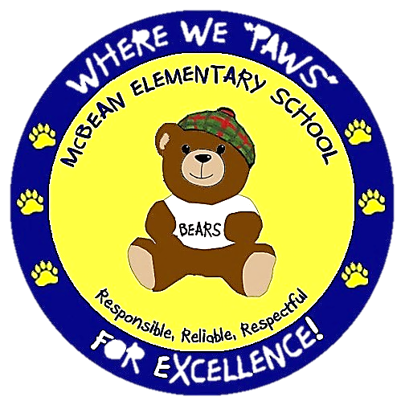  Peer Mentors  ────  Dates and Times

